**Genii Analytics | Weighted AQA and QA**

V1. May 2021

Contents

Purpose 2

# Purpose

This is to show you how to create a new campaign/scorecard on your app.

You will require Client_Admin rights or higher to perform this function.

# Creating a new Campaign

From the menu options go to Management and then Campaigns Management.

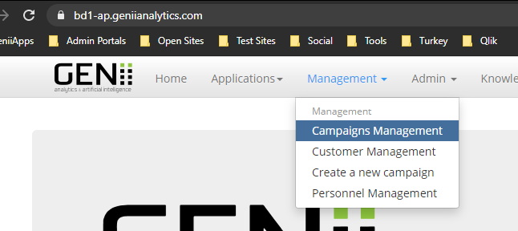

Here you will click on the Create New button.

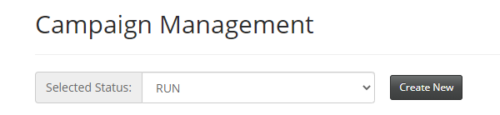



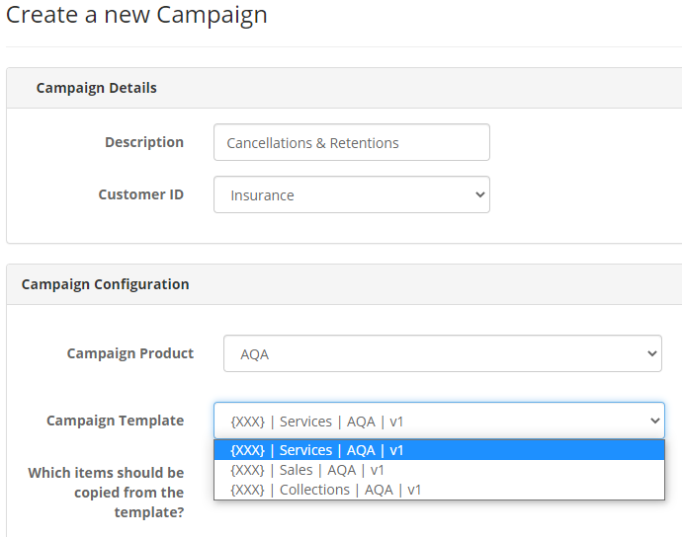

Give your campaign:

1. A name in the Description box
2. Select a DB from that Customer ID (if you have more than one on the app).
3. Select AQA from the Campaign Product
4. Select a Template that best suits your campaign requirements form Campaign Template.

If you want to use a current running campaign, please send your request to appsupport@geniianalytics.com and we will complete this part of the function for you.

Include the above information in your request as well as whether the staff on the current campaign needs to be copied to the new campaign.

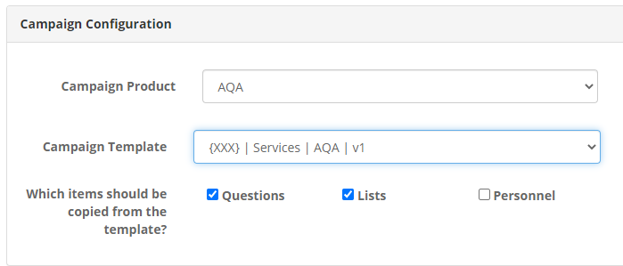

You will have an option to move over the questions, lists and personnel.

It should be noted that there will be no personnel linked to any templates.

Once all this detail has been added click on the Create Campaign button.



You will get the following confirmation notification.

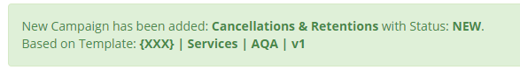

 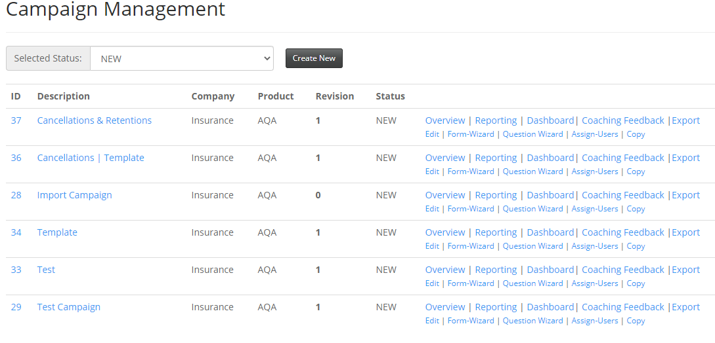

Select New on Selected Status to find your recently created campaign.

You will now need to update:

1. Campaign settings (what can be seen/selected on the Interaction Details Page)
2. Questions (what is seen on the scorecard)

This can be done in any order.

# Campaign Settings

List boxes are a two-step process that can be done in either order.

1. Activate Lists
2. Update/Populate Lists

Below is your campaign before you activate any lists.

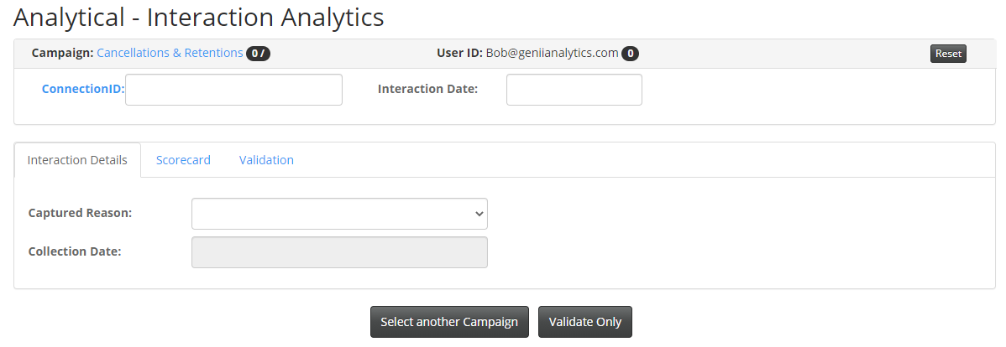

## Activate lists

Go to the Edit Campaign screen.

You can access this clicking the Edit hyperlink on the Campaign Management Page



or the Edit Campaign button on the Overview page

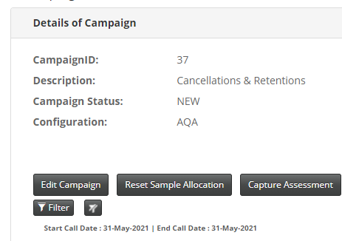

You will come to this page:

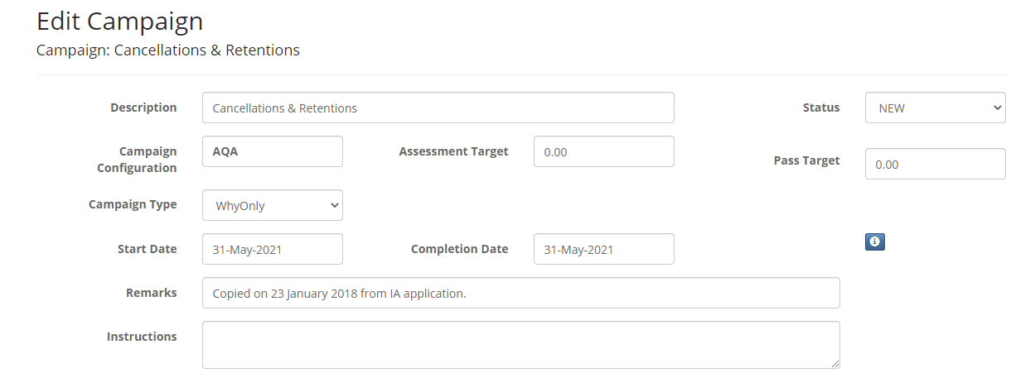

On this part of the page, you will update the following:

1. Status to RUN – this allows your analysts to see the campaign if it is assigned to them.
2. Pass Target, what is the percentage of assessments that need to make 100%.

The Assessment Target for AQA is hard set to 100%.

1. Start and Completion Date (date range for assessments, this will also become the filter defaults). Best Practice – Previous and Current Month.
2. Instructions (any instructions you want to display on the Interaction Details page)

You will find this part of the page when you scroll down.

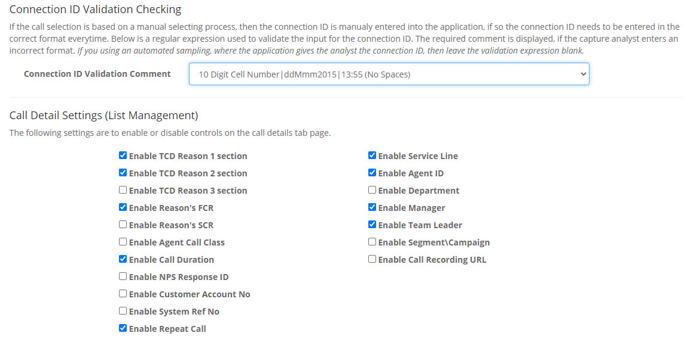

Under Connection ID Validation Checking, you will select your Connection ID from the available formats.

If you need a new format, please send a request to [appsupport@geniianalytics.com](mailto:appsupport@geniianalytics.com) with 3 (three) to 6 (six) examples of your connection id and we will review and create where possible.

Under Call Details Settings you will add ticks to the list you want. In the screen shot above I have selected:

1. 2 Call reason boxes with a FCR option
2. Call Duration
3. Repeat Call
4. Service Line
5. Agent ID
6. Manager
7. Team Leader

The Agent ID, Manager and Team Leader are managed using People Manager.